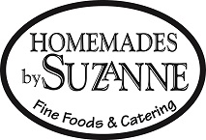

Ashland Lunch Specials

House-made Soup Selections
Thelma’s Vegetable *GF $4.85 bowl / $10.95 Qt

Turkey BLT $11.95
Our house-roasted turkey with Applewood Smoked Bacon,
lettuce and tomato. Side of your choice.

Gluten Free Rolls
are available daily!
*GF indicates Gluten Free Menu Item

